Steam Trap Fault Detection (Temperature + Ultrasound + Cycling)

1. Overview
Detection based on:
- Inlet/Outlet Temperature
- Ultrasound
- Cycles per minute

Mechanical Steam Traps (Float & Thermostatic / Inverted Bucket)
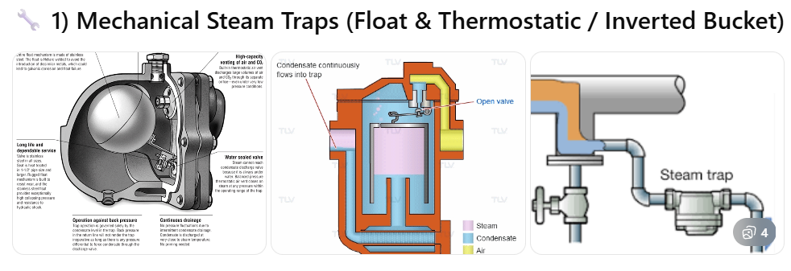
Behavior:
- Continuous or semi-continuous discharge
- Separate condensate and steam mechanically

Fault | Temperature | Ultrasound | Cycles/min
Normal | ΔT small/stable | Continuous/modulated | Low-stable
Failed OPEN | In ≈ Out (hot) | Continuous high | No cycling
Failed CLOSED | In hot / Out cold | Silent | No cycles
Degraded | Fluctuating | Irregular | Irregular
Excessive cycling | Fluctuating | Frequent pulses | High

Thermodynamic Steam Traps (Disc)
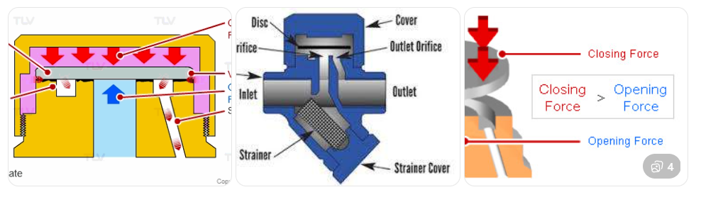
Behavior:
- Operate in cycles (open/close)
- Short bursts of discharge
Fault | Temperature | Ultrasound | Cycles/min
Normal | Fluctuating | Pulsed regular | Moderate
Failed OPEN | In ≈ Out (hot) | Continuous | No cycles
Failed CLOSED | In hot / Out cold | Silent | No cycles
Short cycling | Rapid fluctuation | Very frequent pulses | High
Excessive cycling | Fluctuating | Very fast pulses | Very high

Thermostatic Steam Traps (Bellows)
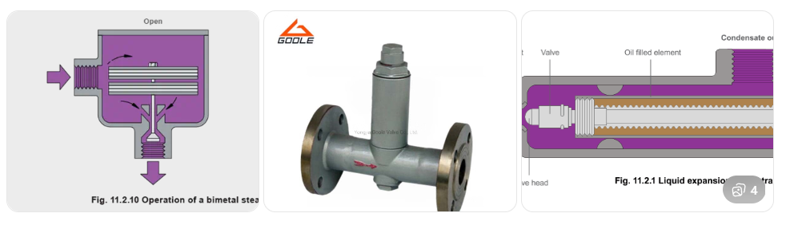
Behavior:
- Open/close based on temperature difference
- Discharge cooler condensate

Fault | Temperature | Ultrasound | Cycles/min
Normal | Out < In | Low/intermittent | Low
Failed OPEN | Out ≈ In | Continuous | No cycles
Failed CLOSED | Out cold | Silent | No cycles
Degraded | Unstable ΔT | Irregular | Irregular
Excessive cycling | Fluctuating | Frequent pulses | High

